**MOVIE TICKET BOOKING SYSTEM**

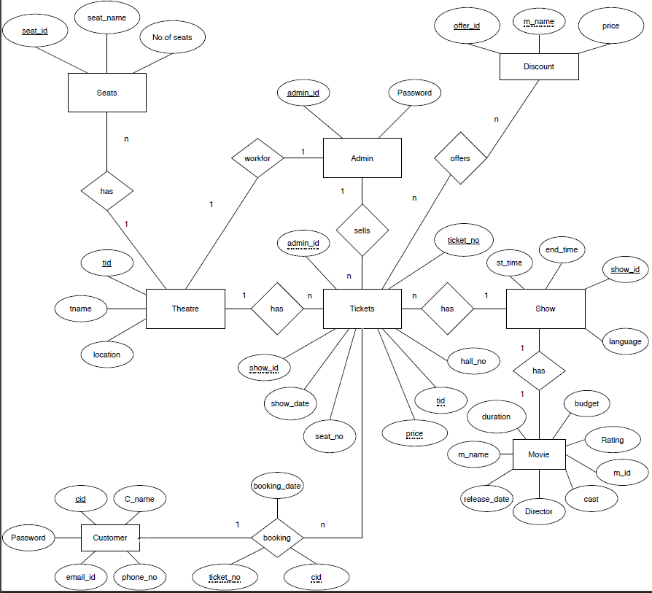**ABSTRACT: ER DIAGRAM:**

The Movie Ticket Booking System Mini Project in Database Management System

integration aims to develop a robust application for managing the process of

booking movie tickets. This system is designed to enhance user experience

by providing a seamless and efficient ticket booking process while

also offering administrators tools for managing movie screenings and bookings.

**Key features of the system include:**

**DONE BY**

**KARTHIKEYA DEVARLA(RA2211003010192)**

**SIDDARTH JAVVADI(RA2211003010154)**

**GOWTHAM REDDY KOMMEPALLI(RA2211003010169)**